 

# Placement Empowerment Program

***Cloud Computing and DevOps Centre***

Automate Static Website Deployment Locally:

Create a script that updates your server whenever changes are pushed.

Name: Sharon Hanna A Department:Ads



# Introduction

In this Proof of Concept (PoC), we aim to automate the deployment of a static website to a local Apache server using Git hooks. Specifically, the post-receive Git hook will be configured to trigger a deployment process after changes are pushed to the Git repository. By setting up this automation, we can ensure that the latest code changes are immediately reflected on the live website without needing manual intervention.

# Overview

This PoC demonstrates the integration of Git hooks, Apache, and a local Git repository for automating the deployment of static websites. The process consists of:

1. **Setting up a Bare Git Repository**: A repository that acts as a remote for receiving code changes.
2. **Configuring the post-receive Git Hook**: A script that will run after code is pushed, which pulls the latest changes and deploys them to the Apache htdocs directory.
3. **Automating the Deployment**: The script will automate the process of pulling the latest code and restarting the Apache server to reflect the changes immediately.

In this PoC, the local machine will be used to demonstrate the deployment process on a Windows environment with Apache running the static website.

# Objectives

The primary objectives of this PoC are:

1. **Automate Static Website Deployment**: Set up an automated system where changes pushed to a Git repository are automatically deployed to the Apache web server.
2. **Enhance Development Efficiency**: Simplify the process of updating a static website without requiring manual file transfers or server restarts.
3. **Implement Version Control for Static Websites**: Use Git as a version control system to track changes to the static website code and deploy those changes automatically.
4. **Test Automation on Local Setup**: Set up and test the automation on a local environment before applying it to production systems.

**Importance**

Automating static website deployment using Git hooks is important for the following reasons:

1. **Efficient Updates**: With the post-receive hook in place, any changes pushed to the repository are automatically deployed, reducing the time spent manually copying files to the server and restarting services.
2. **Consistency**: This automation ensures that the correct version of the website is always deployed, reducing the chances of human errors during deployment.
3. **Streamlined Development Workflow**: Developers can focus on writing code rather than manually managing deployments, leading to a smoother workflow and more rapid development cycles.

# Step-by-Step Overview

## Step 1:

Open GitBash and Create a bare repository to receive the code updates:

## Step 2:

**Navigate to your Apache htdocs directory.** Based on your setup, it should be:

## Step 3:

Next, we'll set up the post-receive hook to automatically deploy your code whenever changes are pushed and **Save and close the file.**

Press Ctrl+O and then press Enter to save. Press Ctrl+X to exit.

## Screenshot 2025-02-13 222701.pngStep 4:

Make the hook executable:



## Step 5:

Now, we'll link your development repository to the bare repository and push some changes to test the deployment.

## Step 6:

**Create or edit an index.html file.** This is just for testing:



## Step 7:

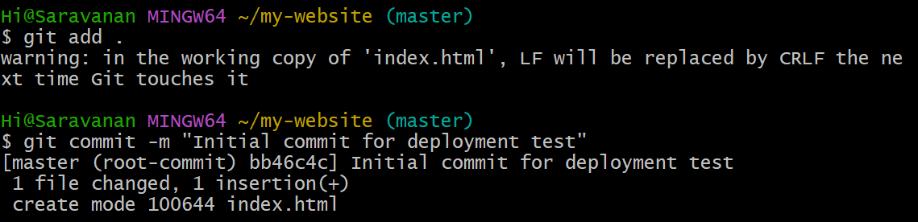Add the files, commit the changes:

## Step 8:

Add the correct remote URL and push the changes

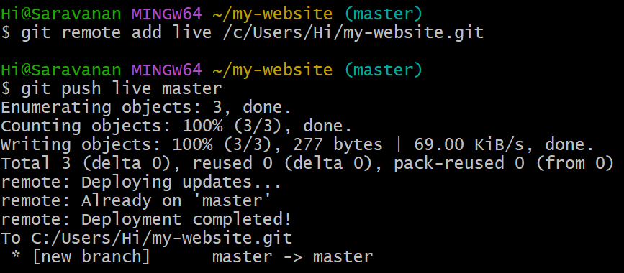

## Step 9:

1. **Open your browser** and go to [http://localhost.](http://localhost/)

You should see the message: **"Hello, Automated Deployment!"**

from the index.html file you just pushed.

### Verify the website update:

If you see the changes, then the deployment is working as expected! The post-receive hook has automatically deployed your code after the push.



# Outcomes

By completing this PoC of automating static website deployment using Git hooks, you will:

### Set Up and Configure a Bare Git Repository:

Learn to create and configure a bare Git repository for automatic deployment.

### Automate Deployment Using Git Hooks:

Implement the post-receive Git hook to automate deployment whenever updates are pushed to the repository.

### Script Deployment and Server Restart:

Gain experience scripting the process of pulling code changes and restarting the server to deploy them.

### Streamline Development Workflow:

Save time by automating the process of updating the live website, reducing manual effort in the deployment process.

### Troubleshoot Deployment Issues:

Build problem-solving skills by addressing common issues related to code pushes, file permissions, and server configurations.